Problem 1

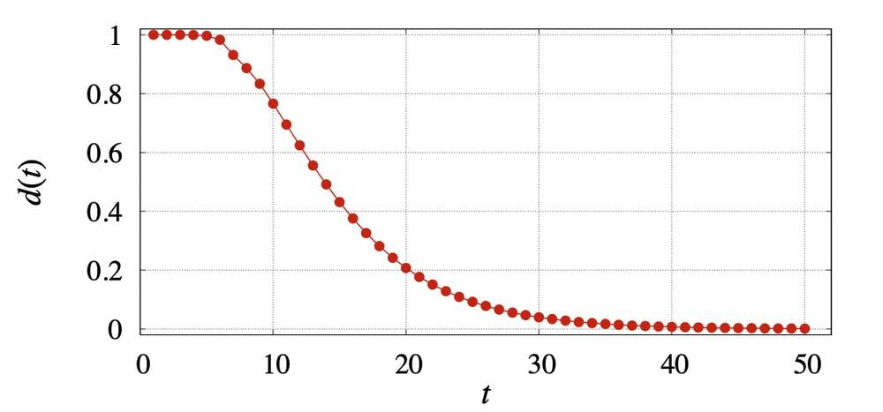

I found a news article which tells about how hard it is to scramble the Rubik's Cube. This graph is a line graph with dots and there is no any histogram, I couldn’t find any news which has a histogram. So, I will analyze and explain the measures of this graph.

There would be only approximate values I consider to be true as I calculate the mean and median here.

The mean would be if I consider the d(t) as the independent variable, it is 0.5 . The median is the two values 0.6 and 0.4 added and divided by two. So, it would be 0.5 again. We got the same mean and median if we consider the d(t) as the independent variable. And I don’t see any mode here.

Here is a small explanation I found about this graph. It explains what d(t) and t are on the graph.

In the graph below, we plot *d(t)* for the pocket cube. After 11 moves, *d(t)* is still very large, at 0.695. The first value of *t* that yields a *d(t)* value below 0.25 (often called “the mixing time” in Markov chain theory) is 19. After 25 moves *d(t)* is 0.092; after 50 moves it is 0.0012; and after 100 moves it is 0.00000017.

Problem 2

1.c

2.a

3.b

Thank you

Student : 201923250

Name : Kobilov Ilkhomjon